# IMAT3406_2021_501 Fuzzy Logic & KBS (AI)

Alex McIntosh - P17188209

Contents

Title Page 1

1. Introduction 2

2. Literature Review 3

3. Overview of Approach 4

4. Technical Description of System 5

5. Experimental Design and Evaluation 7

6. Reflection and Conclusion 10

7. References and Bibliography 11

8. Appendices 11

## Abstract

The brief of this assignment is to design, build, test and evaluate a Mamdani fuzzy logic inference system on a chosen topic. This includes researching relevant data for guidance and inspiration and testing the system with real world data or theoretical data created by the system designer. The Fuzzy Inference System (FIS) must include a minimum of three input variables and one output variable. This system will be created in MATLab (Mathworks) and utilize external data for testing purposes stored using Excel (Microsoft) tables.

This report details the development of a Fuzzy Inference System to determine the level of interest a customer will have for a new product being introduced to the ecommerce site, determine if the customers interest level warrants advertising being placed on the site and the frequency of the adverts that should be supplied to the customer. This has been chosen as the topic of the FIS to demonstrate how Fuzzy Logic can be applied to an ecommerce site, and how focusing adverts on groups likely to make a purchase can lead to an increase in sales. The UK leads Europe in Online Purchases, with 87% of individuals having made a purchase online in the past 12 months [1], meaning this is an area of use that will increase with time. 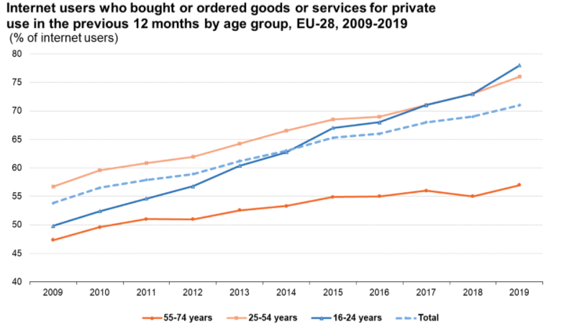

Fig 1. Chart showing the increase in ecommerce activity in the past decade, ec.europa.eu, 2020, *E-commerce statistics for individuals*

This report will also detail the evolution of the Fuzzy Inference System and describe how changes were made to increase performance, and justify the design choices made, and evidence them with testing.

## Introduction

Fuzzy Sets are used to determine the degree of membership an object has to a set. This deviates from traditional crisp sets, where an object is either a member or a set or not. Crisp sets have very clearly defined boundaries, meaning an object will have a membership of either 1 or 0, indicating that the object either belongs to the set or not, whereas an object in a fuzzy set can have a membership ranging from 0 to 1, where 0.99 indicates a very strong membership to the set and 0.01 indicates a very weak membership to the set. As well as this, objects in a fuzzy set can have a degree of membership to multiple sets. In “An introduction to fuzzy systems” D. Dubois & H. Prade, 1983, *Ranking fuzzy numbers in the setting of possibility theory* provide the example of defining ‘old people’ as a class, writing how there is not a clearly defined boundary where a person is suddenly old. They go on to detail how Zadeh proposed modelling guardedness to set membership as a numerical scale, as discussed above using a scale of 0.01 to 0.99.

Fuzzy Inference Systems utilize Fuzzy sets as part of a method to replicate Human decision making as part of 5 steps. Initially the crisp values are fuzzified into object values, then based on the rule base, rules are fired, placing the fuzzy implication onto consequents. The consequents are then combined, and the Fuzzy Output value is defuzzied, giving a crisp output value.

## Literature Review

This Literature Review will develop the definition of Fuzzy Sets written in the introduction and introduce the concept of Fuzzy Inference Systems, explore some of its application in similar use cases, when a product is recommended to a user based on information passed to a FIS, and how the use of a FIS was a benefit or disadvantage to the project of the author.

Khan, Mannan, Eshan, Rahman, Sonet, Hasan, Rahman, (2017). *Tourist Spot Recommendation System Using Fuzzy Inference System* designed a FIS to recommend tourist attractions based on data collected from users, distilled as 6 input variables. The Authors were able to split different location types based on input for the user, for example if a user selects Hills, only data for Hills is retrieved from the database and used in the FIS. The Authors detailed their reasoning for selecting the membership functions for each of the input variables based on their perceived significance, with important variables like safety using a Gaussian Membership function for increased accuracy, and most others using Trapezoidal. The Authors were also able to define a membership function for Beauty (how beautiful a location is) based on the value difference between the pre-defined score for the attraction and the score provided by the user, though this seems poorly designed as beauty is a subjective value, defined by the authors, and when calculated recommends places more if the user rated them the same as the values defined by the Authors and doesn’t account a user rating a with a higher beauty score showing more preference to that spot. A better solution would be to take an average of scores from previous users, to prevent the bias of the Authors being used in the FIS. This is addresses in the Authors conclusion, in which they hope to implement using previous users reviews against users’ preferences.

Muyeed A, Anirudha P, Mir Tahsin I, Md. Zahid H, Shawon Af, Rashedur M, 2017. *TV Series Recommendation Using Fuzzy Inference System, K-Means Clustering and Adaptive Neuro Fuzzy Inference System* detailed how they designed and implemented a FIS to analyse user genre preferability as part of a larger project to project predict user ratings and recommend films and shows they might like similarly to my project of analysing user preferability to recommend products. The Authors designed two FISs, one for television and one for films. In the Film FIS, two input variables to create the User Preferability Fuzzy output variable, User Rating on a scale from zero to ten, and Ratio, the average media consumption of a genre. This was to account for user taste, so a film reviewed lowly by users with a low ratio membership function for that genre would have a high preferability score for a user that has a higher ratio membership function for that genre. The Film Recommendation FIS only takes two fuzzy inputs, meaning fewer inputs can provide only a broad accuracy for the Fuzzy Output of preference. This could be solved by using more Fuzzy Inputs, a point not addressed in the conclusion of the authors work.

Ramirez E. M., Mayorga R. V., 2008. *On the Parameter Optimization of Fuzzy Inference Systems provide insight into the optimization of fuzzy Inference Systems through modification of the membership functions*, measuring changes in the performance of the system and implementing new rules. Through the example of a multiple system Fuzzy Inference System they show the situations for each of the types of membership functions, recommending the use of non-continuous membership functions Trapezoidal and Triangular for data featuring discrete fuzzy variables and Gaussian membership functions for variables that are not. The authors make a point about how to define boundaries between fuzzy variables using both trapezoidal and gaussian membership functions, seen in the graph. The authors attempt to represent discrete variables using a number scale, such as Occupation and Gender.

Guimarães A. C. F, Lapa C. M. F., 2007, *Fuzzy inference to risk assessment on nuclear engineering systems* describe using a Fuzzy Inference system to assess risk on nuclear engineering systems. The Authors used expert recommendation and data to determine the Fuzzy Inputs for their system. The Authors choose to use triangular membership functions in their FIS, though for the Occurrence Input, the value of 0 is not represented by any of the membership functions, potentially preventing rules from firing. To solve this, the authors could have implemented Trapezoidal membership functions at the lower bounds of the chart, as done for the risk fuzzy input. This would provide greater coverage for the lower limits of the membership function and is something planned to be implemented in the FIS design of this project.

Sabri N, S. A. Aljunid, M. S. Salim, R. B. Badlishah, R. Kamaruddin, M. F. Abd Malek,, 2013. *Fuzzy Inference System: Short Review and Design* suggest the use of a Fuzzy inference System is ideal for controlling small, simple embedded systems when data analysis would be too complex for a person to do. The Authors also mention the advantages of providing “*an uncomplicated solution to come to a definite conclusion based upon fuzziness, vague, inexact, noisy, or lacking of input information”.* The Authors write also about the differences between Mamdani and Takagi-Sugeno Fuzzy Inference Systems, the output sets for and Takagi-Sugeno being more complex than Mamdani, and Takagi-Sugeno controllers being used for solving problems with multiple inputs and outputs, while Mamdani is a static equation made to match inputs to outputs.

To determine the most effective Fuzzy Inputs research (what research) was reviewed to find trends amongst ecommerce users in Europe. The research showed that Age was a large factor in whether a user would purchase goods online, with the most peak group being 25-34 years. The Office of national statistics was also used to accurately categorise the groups of Internet Users by Age.

## Overview of Approach

**Deciding on the Fuzzy Input and Output Variables**

Following the information found in the literature review, the design of the Fuzzy Inputs of the system relate to information of the Users of the web site, not the products. Determining human behaviour and emotion using Fuzzy inference is much trickier than measuring mechanical behaviour, as Humans have a wide array of emotions and actions and are capable of disguising intent or can act sub consciously, making collecting data and inferring action complex. This contrasts with measuring something instrumentally, like temperature. A temperature can be measured to provide definite information, the temperature is high so the weather is hot. By contrast measuring an attribute of a human does not have a correlation to behaviour. If a human has an attribute, for example lots of money, this doesn’t correlate to behaviour, such as feeling like they should spend it. To identify users that would be more likely to purchase goods on the site, the definition of the inputs should follow a detective’s investigative process and measure means, motive and opportunity.

To measure means, the Fuzzy Inputs should measure factors of users that had the ability to purchase lots of goods or showed a capability to spend money on the site. Logically, Users with a large account balance on the site would be able to spend more money than someone who doesn’t have the same balance, so should receive higher targeted adverts. Another way to determine the means of the user to make purchases is to use data the Number of Previous Purchases that a User has made. A User that has previously made many purchases on the site possesses the means and ability to make purchases in the future.

To measure motive, the Fuzzy Inputs must measure the intent of a user who shows signs of wanting to purchase goods on the site. The information found in (CITE THE RESEARCH) showed that using age as an input would be advantageous, as younger demographics of people were more likely to purchase goods online than an older user of the site (refence here). Another Input used would be the Wishlist of a User, as a user that had a large Wishlist shows a high level of interest in purchasing goods on the site.

This would identify the ideal candidate for advertising as a user with money to spend on the site, with established history or inclination of purchasing online. To measure this the Five Fuzzy Inputs defined in the FIS are User Age, Account Balance, Number of Previous purchases and Wishlist for the reasons provided above.

**Creating the Rule Base**

The Rule base should provide outcomes for all possible inputs to the system, with all possible combinations resulting in 320 rules. Due to the design of the rulebase featuring all outcomes the operator used for the rulebase is the AND operator.

## Technical Description of System

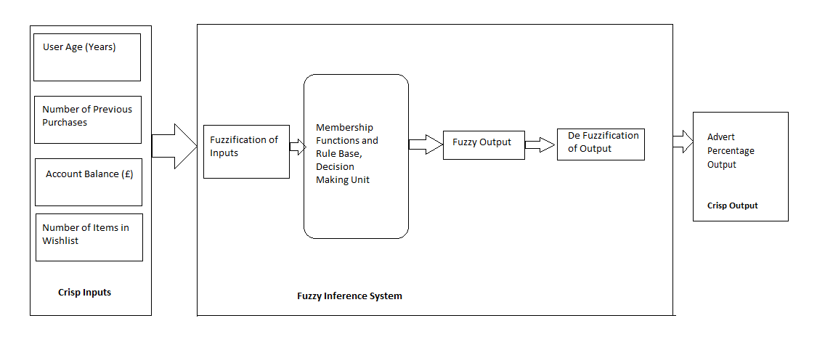

Fig 2. – Diagram of the Advertising Percentage FIS

The technical description can be found in the appendix then here put the fuzzy input ranges. Can move the diagrams to the Appendix later if needs be

**Choosing the Input and Output Variables and Set**

The Fuzzy Ranges of Values for the Fuzzy Input Variables were based on insights based on E-commerce statistics for individuals (cite here), as well as site specific inputs of the ecommerce site. The Fuzzy Output will be buying potential, that can be reflected as level of adverts that the user should receive. The Inputs used to determine interest in the site are:

1. User Age – the age of the user (Years)

This Input has 4 levels, Young Adult, Adult, Middle Aged and Retired. The Membership functions highest value is 80 to reflect the age of internet users shown by the UK Gov Office of National statistics. While the number of users aged 75 and older has been growing from 20% in 2011 to 47% in 2019, they are consistently the lowest. Users of the internet, and users in the 80-100 age bracket is non-existent. The Lower limit of the range is 10, keeping with the policy of the site.

1. Account Balance – The Amount of Money on the Account (Pounds Sterling).

This Input 5 levels, None to Very Low Balance, Low Balance, Fair Balance, High Balance and Wealthy Balance. The upper Limit of the membership function is £300. This was chosen as the e commerce site sells only small goods, and while the user can have an account balance larger than the upper limit, the classification of Wealthy Balance would not change. This input was originally 4 inputs but was changed to add very low balance to reflect the Users that had little to no balance. Wealthy has been added as well as high balance to show an excess of money in the account.

1. Number of Previous purchases – The number of purchases the account has made.

This Input has 4 levels, defined as Isolated Customer, Occasional Customer, Normal Customer and Frequent. The Upper limit of this membership function is 10, with a Frequent Customer being defined as 10+. This Fuzzy Input has a lower limit of 0 as a customer can visit the site and not make a purchase.

1. Wishlist – the number of items a user has on their Wishlist.

This Input 4 levels, No Wishlist, Small Wishlist, Moderate Wishlist, Large Wishlist. This Input was chosen to determine if users have purchased on the site before and so show a desire to purchase goods on the site. The Upper limit of this membership function is 10, with a Frequent Customer being defined as 10+.

The Fuzzy Output of this FIS is Advert Percentage, defined as the level of adverts that the user should get respectively.

1. The Advert Percentage Output

a Percentage scale and has 4 levels, No / Minimal Advertising, Low Advertising, Regular Adverts and Targeted adverts, each corresponding to a level of adverts. Anything under 20% has full membership to No / Minimal Advertising.

|  |  |  |  |
| --- | --- | --- | --- |
| **Variable** | **Type of Variable** | **Range** | **Intervals** |
| User Age (Years) | Input | 18 - 80 | Young Adult, Adult, Middle Aged and Retired |
| Account Balance (£) | Input | 0 - £300 | None to Very Low Balance, Low Balance, Fair Balance, High Balance, Wealthy Balance |
| Number of Previous Purchases | Input | 0 – 10+ | Isolated Customer, Occasional Customer, Normal Customer and Frequent Customer |
| Number of Items in Wishlist | Input | 0 – 10+ | No Wishlist, Small Wishlist, Moderate Wishlist, Large Wishlist |
| Advert Percentage (%) | Output | 0 - 100% | No / Minimal Advertising, Low Advertising, Regular Adverts, Targeted adverts |

Fig. 3 - Inputs and Output used in the Advert Percentage FIS

For all inputs trapezoidal membership functions were used to represent the interval values in the membership functions, and trapezoidal membership functions were used at the upper and lower limits of the range as the absolute upper and lower values can have values that represent 100% membership.

**Designing the Rulebase**

The full rulebase can be found in the appendices (Appendix Fig. 5). The rulebase was designed in Microsoft Excel as a matrix (Appendix Fig. 4) to show all outcomes of the FIS. While there are a lot of rules for the fuzzy system by programming all outcomes, it ensures that all possible input values are covered and all rules fire. Following a functional Inference system, with all the rules firing the rulebase can be edited.

## Experimental Design and Evaluation

**Testing**

The system was tested using 25 entries featuring random values across the ranges. The specific values are shown in the appendix. After the initial test, 5 rules did not fire and replaced the crisp output with the mean value. All values featured Number of items in Wishlist over 8, test numbers 1, 7, 13, 17, 18 and 25. This was a problem with the rulebase having duplicate rules, with a lot of rules featuring a 3 for input variable 4, Number of items in Wishlist. Following the correction of the rulebase, the test was ran again, and all rules fired successfully, outputting the predicted result.

As all the system rules fire, the testing of perform and enhancement was able to begin. The system uses a defuzzification method of Centroid as default, so for the second test the parameters were changed to use the Large of Maximum (LOM), Small of Maximum (SOM) and Medium of Maximum (MOM) Mamdani Fuzzy Defuzzification Methods. The results for these tests can be seen in the appendix (REF HERE). The use of SOM was found to not represent the predicted outcomes of the advertising levels, as shown in tests 11 and 18, as users with a score of No/Minimal Advertising shouldn’t receive an advertising percentage of 0. The use of LOM defuzzification method should be used to maximise sales, as it provides the highest advertising percentage for targeted groups.

**FIS 2 – Customer Interest and Advertising Percentage**

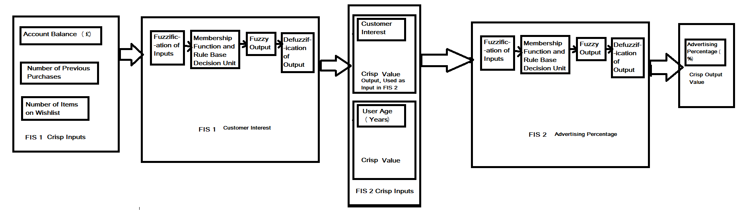Following the initial design of the system, changes were made to improve the accuracy of the rule base and reduce the number of rules used in the system, the initial design of the FIS was changed to first determine the interest of the user and the buying potential of the user, use those values as fuzzy inputs to determine the level of advertising that the user should receive. The initial design of the FIS would require 320 rules for each possibility to be defined, so splitting the FIS into two smaller systems allowed the removal of extreme cases and reduced the number of rules to 96.

Fig 4 – Diagram of the Customer Interest FIS and Advertising Percentage FIS (FIS2)

The First System of FIS2 is used to measure the interest of users in the site, using Account Balance, Number of Previous Purchases and Number of Items in Wishlist as Input. The range of the Number of Wishlist items membership function for Small Wishlist was changed to overlap more with the No Wishlist function. Now the FIS functions that if a user has zero previous purchases, they will be fuzzified into No Wishlist, but anything over that will be fuzzified into small Wishlist. The range was also expanded to account for up to 20 items and the ranges updated, to create more specificity, and allow users with up to 20 and over 10+ items. The Range for number of previous purchases was also updated to 30 to allow for a greater range of values and more specificity in the fuzzification methods.

|  |  |  |  |
| --- | --- | --- | --- |
| **Variable** | **Type of Variable** | **Range** | **Intervals** |
| User Age (Years) | Input | 18 - 80 | Young Adult, Adult, Middle Aged and Retired |
| Number of Previous Purchases | Input | 0 – 30 | Isolated Customer, Occasional Customer, Normal Customer and Frequent Customer |
| Number of Items in Wishlist | Input | 0 – 20 | No Wishlist, Small Wishlist, Moderate Wishlist, Large Wishlist |
| Customer Interest (%) | Output | 0 - 100% | No Interest, Low Interest, Medium Interest, High Interest |

Fig. 5a - Inputs and Output used in the Customer Interest FIS as part of FIS 2

|  |  |  |  |
| --- | --- | --- | --- |
| **Variable** | **Type of Variable** | **Range** | **Intervals** |
| User Age (Years) | Input | 18 - 80 | Young Adult, Adult, Middle Aged and Retired |
| Customer Interest (%) | Input | 0 - 100% | No Interest, Low Interest, Medium Interest, High Interest |
| Advert Percentage (%) | Output | 0 - 100% | No / Minimal Advertising, Low Advertising, Regular Adverts, Targeted adverts |

Fig. 5b - Inputs and Output used in the Advert Percentage FIS as part of FIS 2

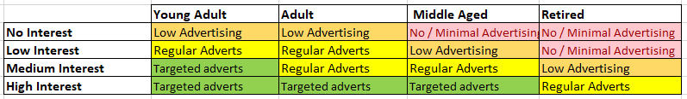The membership functions for the Account Balance Input was updated to provide greater specificity, as in FIS1 half of the range was covered by two inputs (Wealthy Balance and High Balance), while a third was covered by three ranges (None to Very Low Balance, Low Balance, Fair Balance). The membership functions were changed to be gaussian to provide greater accuracy, and the Fair Balance input was expanded to have a wider range than the others, as this is the range most users are expected to fall into. The range for Very Low Balance was expanded, as in FIS1 it was featured in a fifth of the rules, while the membership function covered only 1.67% of the total range. The membership functions for the Output were updated to be gaussian and the Medium interest output changed to be the widest range, spanning over 40% of the Chart. The new membership function can be seen in Fig. 13 in the appendix.

Fig. 6 – The adjacency matrix for FIS 2

The rulebase for both systems were generated using the same methodology of FIS1, with rules being made for all outcomes of the system. FIS2 featured 96 rules, a lot less than FIS1, which featured 320 rules. The Rulebase can be found in Figures 15 & 16 in the appendix.

**System 1 FIS Testing**

The test data for FIS2 was created using the same random value generation used to make the test data for FIS1. The ranges were updated for Number of Items and Number of Previous visits inputs. Following the initial running of FIS2, rules that had a value of 15 for number of previous visits didn’t fire. After looking at the membership functions, none of the membership functions covered the value of 15. The functions were changed and implemented and following this the systems rules all fired from the test data.

Following the initial running of System 1, FIS 2 the randomly generated test values were found to be unsuitable for testing extremes for the system, as most of the test resulted in High Interest being generated as the output membership function, and only one occurrence of No Interest. The values of the test cases were updated to test for extreme values of the maximum and minimum allowed by the membership functions and to feature at least 5 entries for each of the outputs. The updated test values can be seen in Appendix Fig. 17.

After the rules of FIS2 all fired, the defuzzification methods were changed to allow use of Bisector, SOM, LOM and MOM to see which provided higher performance. The best performing Defuzzification methods for System 1 were the Centroid and Bisector Defuzzification method. The SOM method was excluded as it provided a value of 0 for customers with an interest value, making It unsuitable for the business problem. The LOM method was excluded as all the outputs for High Interest were 100, providing no difference across the range, making it unsuitable as all users would receive the maximum level of advertising. The MOM Defuzzification method was excluded as it provided incorrect outputs for tests 16 and 18, showing it had a problem classifying users with a Medium Interest. The Full testing data can be seen Appendix Figure 18.

The Centroid Defuzzification Method was chosen as it provided greater accuracy of Output values, as the values for Bisector would be rounded up to the nearest whole number a lot of the time, indicating increased interest that wasn’t accurate, and would provide inaccurate output in System 2 of FIS2.

**System 2 FIS 2 Testing**

The testing values were updated to allow all age groups to be included in the testing process. As the new values are generated by System 1 all ages were included for the new inputs featuring No Interest and Low Interest. All rules fired successfully, at which point the output was changed to use all defuzzification methods to measure the effect on the accuracy of the output. The SOM defuzzification method performed successfully but was excluded as it was unsuitable for the business problem as the amount of advertising wouldn’t be enough to capitalize on the interest of the Users. The LOM method was also deemed to be unsuitable as all Targeted advert outputs were 100%, which could be overbearing for Users that have a low membership to the Targeted Adverts membership function and could cause reduced activity on site. The Bisector and Centroid methods performed identically well, thought the selected defuzzification method chosen was MOM, as it provided greatest accuracy for the business problem, meaning it was accurate and providing increased percentage of advertising level for those users that showed interest. For example, in tests 19 and 20, the MOM defuzzification method provided an accurate value for targeted adverts, while providing an increased percentage than the Centroid and Bisector methods. Conversely in test 29, the Output was successfully accurate for the No / Minimal Advertising Membership function, while providing a lower Advert Percentage than Centroid and Bisector methods. All testing data can be found in

## Reflection and Conclusion

In conclusion, the second FIS suits the business problem better, using the MOM (Middle of Medium) defuzzification method would work best for this problem, as this method is able to correctly output values for the membership function while performing better than Centroid and Bisector in accurately predicting what the Output should be for the User. All problems found with the system were with the membership functions being coded incorrectly and not covering some of the values, though this was found in testing and easily changed.

The performance of the system is satisfactory though could be improved by implementing more input variables and more data points of users.

Problems with the design of the system revolved around difficulty finding inputs to use for the system. This was solved initially by applying the trends seen in the e commerce statistics though a lot of the trends couldn’t be used as they had values that were too clearly defined. Implementing variables like gender, for example, which is (in the example of trends found) a binary variable. This meant, while including as a viable would improve the system performance, it would be hard to use in a Fuzzy system as it has very clear, well defined boundaries. Another problem was that a lot of the proposed inputs were like other variables. In the original design of the first fuzzy system, there was an input variable of Number of visits to site, though this was found to be too similar to the Number of previous purchases variable, and ultimately removed.

Another problem was the idea for using a fuzzy system to measure the behaviour of humans. This is touched on in the Overview of approach section, as developing a system to classify humans by behaviour is harder than developing a system that can measure variables using instruments, like a thermometer. Should another system be developed, it would base inputs on instrumental measurements. This would also help with inputs not being fuzzy, as only one of the variables used in the FIS was a decimal value, with all others being whole numbers.

Another area that the FIS could be improved is increased testing for FIS1. The test cases should have covered a wider area and boundaries of the Membership functions, a problem corrected in the design of the test cases for FIS2.

Speaking personally, I’m satisfied with the functionality of my system and feel that the mistakes made initially were necessary for understanding Fuzzy Logic better and are learning experiences I will remember and use when developing anything using Fuzzy logic in the future. I really enjoyed the content of the module and would recommend for any Computer Science students at De Montfort. I found the Lectures and Labs clearly laid out and easy to understand and would like to thank Archie for always being available to answer questions or help go through something again if I needed it.

## References and Bibliography

[1] Sabanoglu, T, 2020, *E-commerce in the United Kingdom (UK) - Statistics & Facts*, statista, viewed 25/10/2020, <https://www.statista.com/topics/2333/e-commerce-in-the-united-kingdom/#:~:text=According%20to%20the%20most%20recent,increase%20on%20the%20year%20prior>.

[2] ec.europa.eu, 2020, *E-commerce statistics for individuals*, eurostat, viewed 25/10/2020, <https://ec.europa.eu/eurostat/statistics-explained/index.php/E-commerce_statistics_for_individuals#General_overview>

[3] Khan H., Mannan N., Eshan S. C., Rahman M. Md, Sonet M., Hasan W., Rahman R. M., 2017, *Tourist Spot Recommendation System Using Fuzzy Inference System*, Bangladesh, Department of Electrical and Computer Engineering, North South University, pg. 1532 – 1539.

[4] Muyeed A., Anirudha P, Mir Tahsin I., Md. Zahid H., Shawon A., Rashedur M R., 2017, *TV Series Recommendation Using Fuzzy Inference System, K-Means Clustering and Adaptive Neuro Fuzzy Inference System*, Bangladesh, Department of Electrical and Computer Engineering, North South University, pg. 1540 – 1547.

[5] Ramirez E. M., Mayorga R. V., 2008, *On the Parameter Optimization of Fuzzy Inference Systems*, 2008, International Journal of Computational Intelligence 4;1 2008, pg. 1-14

[6] Naseer Sabri, S. A. Aljunid, M. S. Salim, R. B. Badlishah, R. Kamaruddin, M. F. Abd Malek, *Fuzzy Inference System: Short Review and Design*, 2013, Perlis, International Review of Automatic Control (I.RE.A.CO.), Vol. 6, N. 4

[7] Guimarães A. C. F, Lapa C. M. F., *Fuzzy inference to risk assessment on nuclear engineering systems*, 2007, Rio de Janeiro, Elsevier, pg. 18-28.

[8] Dubois D., Prade H., *Ranking fuzzy numbers in the setting of possibility theory,* 1983, Volume 30, Issue 3, Pages 183-224

## Appendices

**Pre-Testing Membership Functions of FIS 1**

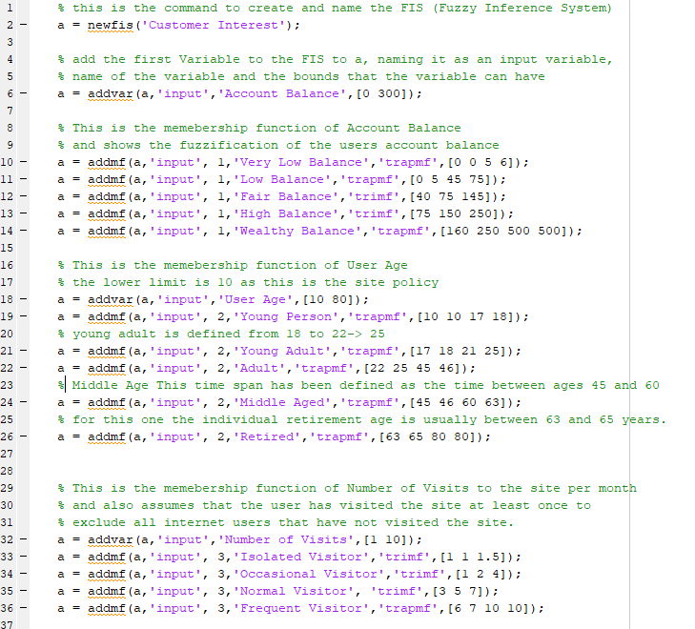

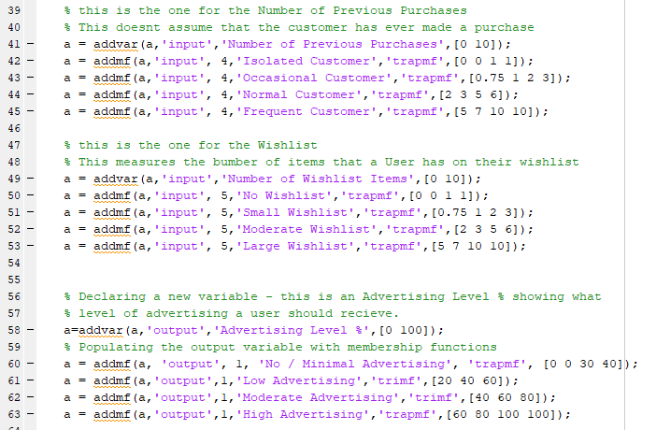

Fig 1 . Membership Functions of FIS 1

FIS 2 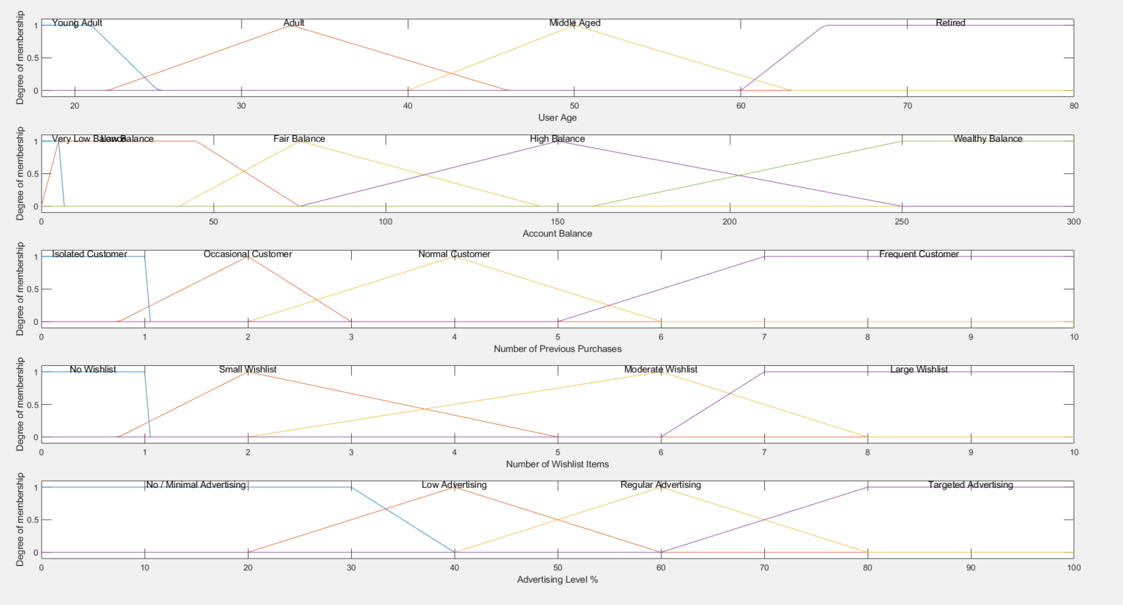

Fig 2. FIS 1 Initial Distribution

**After Testing Membership Functions for FIS 1**

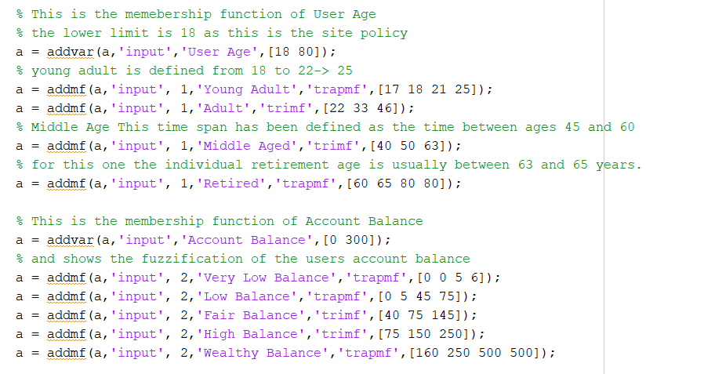

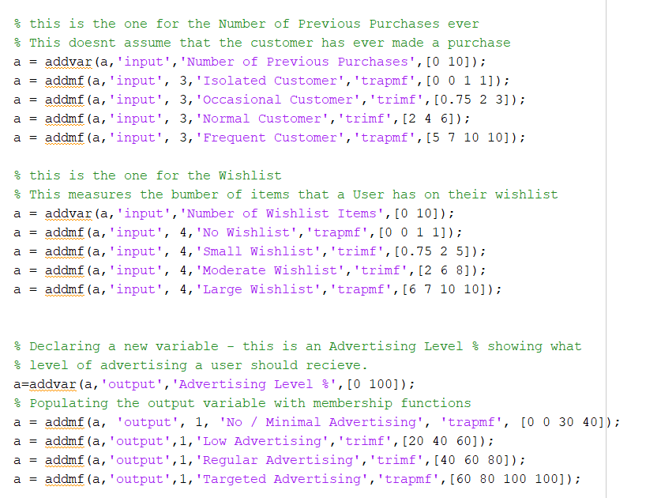

Fig 3. FIS 1 Rule Base following testing

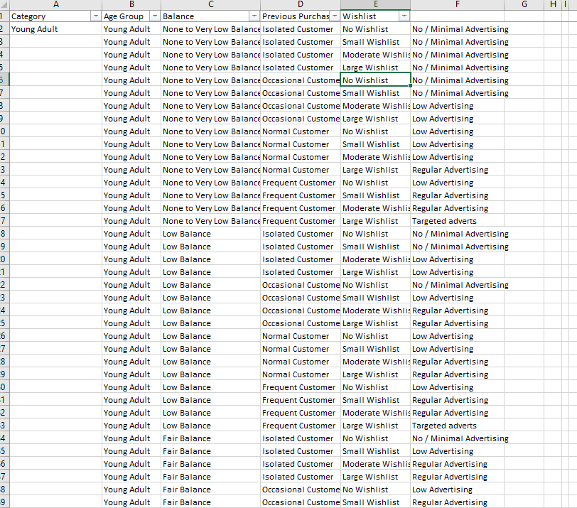

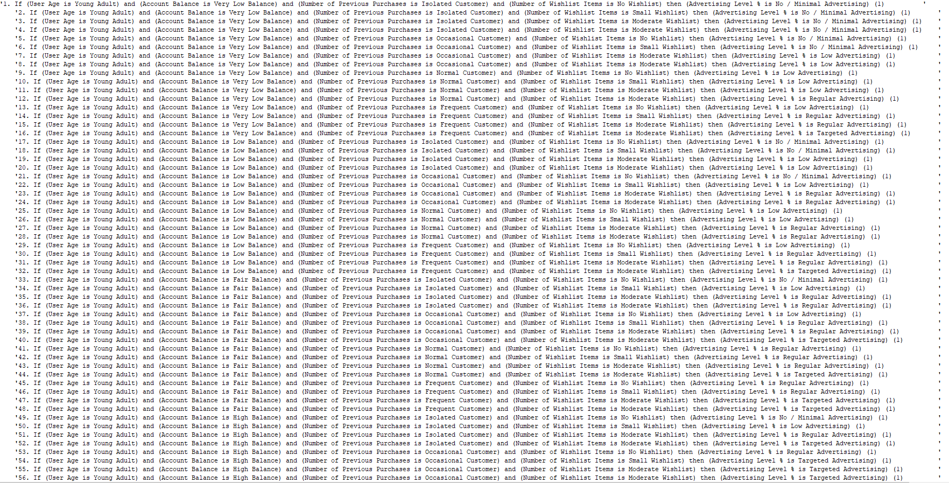Fig 4 .The Matrix used to design the rulebase.

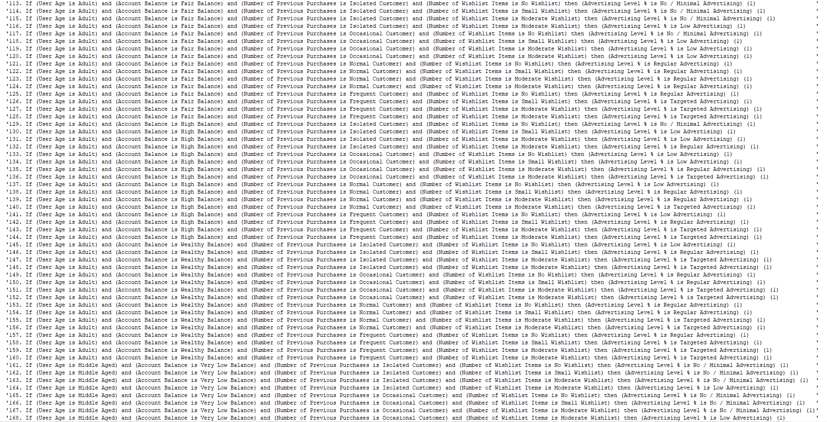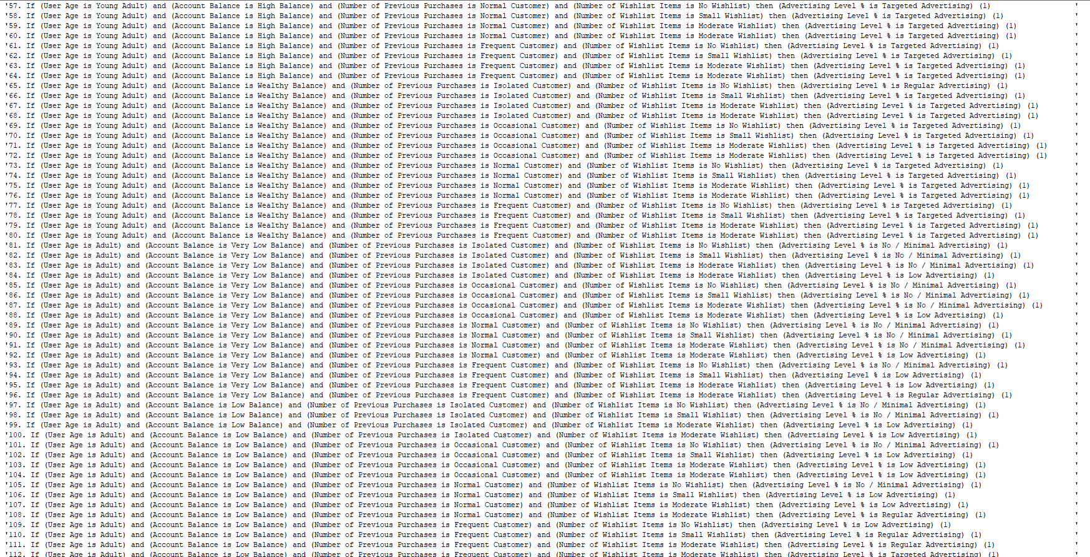

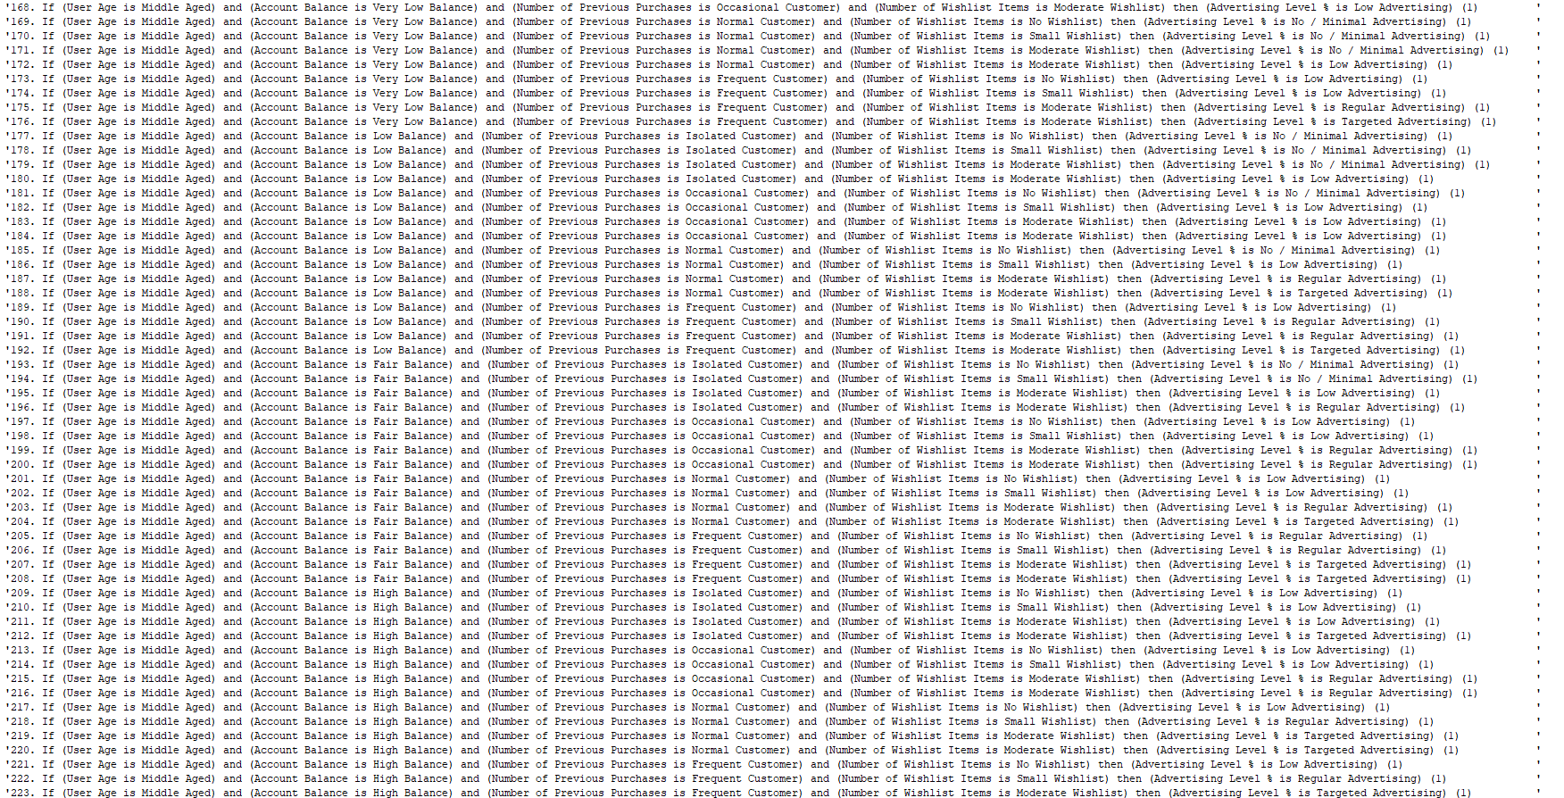

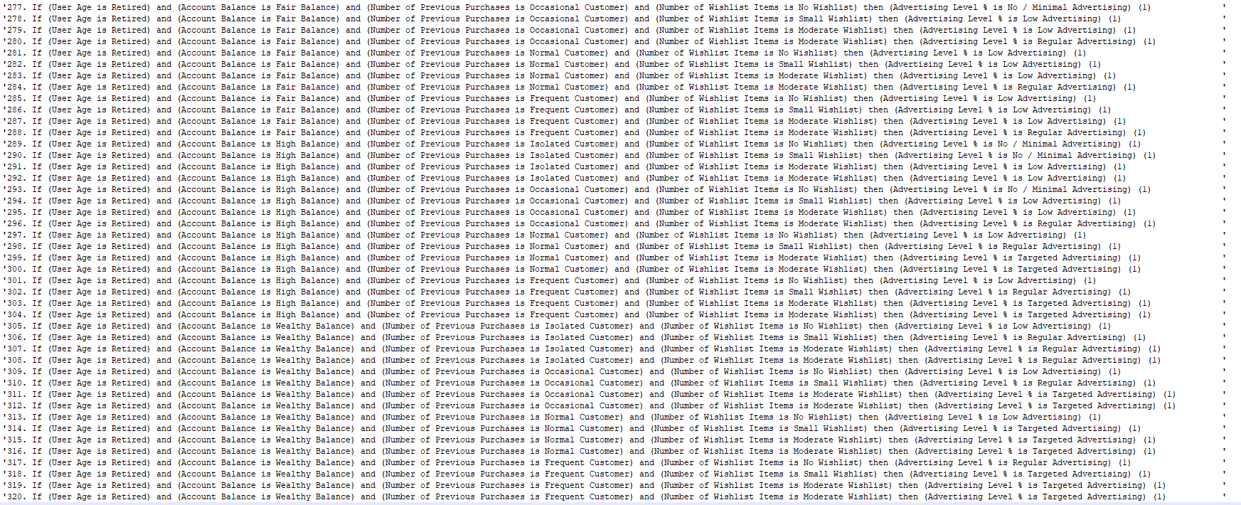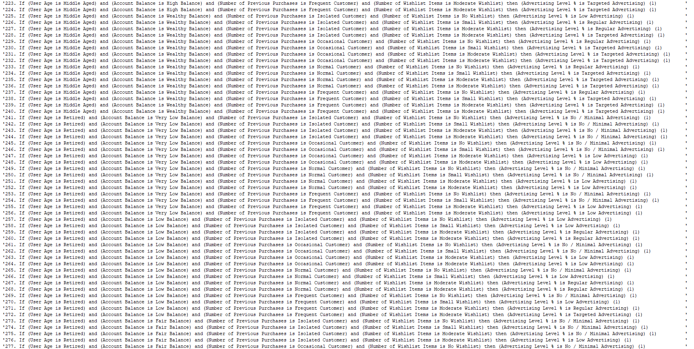Fig 5. - The Rulebase for the FIS1

**Testing Data**

|  |  |  |  |  |
| --- | --- | --- | --- | --- |
| **Test Number** | **User Age** | **Account Balance** | **Number of Previous Purchases** | **Number of Items in Wishlist** |
| 1 | 21 | 175 | 7 | 8 |
| 2 | 64 | 279 | 7 | 6 |
| 3 | 48 | 5 | 7 | 7 |
| 4 | 25 | 250 | 3 | 6 |
| 5 | 24 | 180 | 1 | 6 |
| 6 | 64 | 198 | 5 | 10 |
| 7 | 30 | 70 | 2 | 8 |
| 8 | 49 | 158 | 1 | 3 |
| 9 | 61 | 63 | 1 | 6 |
| 10 | 79 | 280 | 6 | 6 |
| 11 | 30 | 107 | 8 | 6 |
| 12 | 77 | 41 | 8 | 3 |
| 13 | 23 | 281 | 5 | 10 |
| 14 | 68 | 158 | 2 | 3 |
| 15 | 48 | 18 | 4 | 7 |
| 16 | 45 | 52 | 1 | 4 |
| 17 | 44 | 221 | 3 | 10 |
| 18 | 63 | 170 | 4 | 8 |
| 19 | 22 | 151 | 10 | 2 |
| 20 | 27 | 77 | 6 | 5 |
| 21 | 26 | 284 | 1 | 3 |
| 22 | 47 | 87 | 2 | 7 |
| 23 | 58 | 261 | 6 | 4 |
| 24 | 22 | 14 | 7 | 2 |
| 25 | 35 | 22 | 2 | 8 |

Fig 6. Test Data for FIS 1

|  |  |  |  |  |  |
| --- | --- | --- | --- | --- | --- |
| **Test Number** | **User Age** | **Account Balance** | **Number of Previous Purchases** | **Number of Items in Wishlist** | **Expected Outcome** |
| 1 | Young Adult | High Balance | Frequent Customer | Large Wishlist | Targeted adverts |
| 2 | Retired | Wealthy Balance | Frequent Customer | Moderate Wishlist | Targeted adverts |
| 3 | Middle Aged | None to Low Balance | Frequent Customer | Large Wishlist | Targeted adverts |
| 4 | Adult | Wealthy Balance | Normal Customer | Moderate Wishlist | Targeted adverts |
| 5 | Young Adult | High Balance | Isolated Customer | Moderate Wishlist | Regular Advertising |
| 6 | Retired | High Balance | Normal Customer | Large Wishlist | Targeted adverts |
| 7 | Adult | Fair Balance | Occasional Customer | Large Wishlist | Regular Advertising |
| 8 | Middle Aged | High Balance | Isolated Customer | Small Wishlist | Low Advertising |
| 9 | Retired | Fair Balance | Isolated Customer | Moderate Wishlist | Low Advertising |
| 10 | Retired | Wealthy Balance | Frequent Customer | Moderate Wishlist | Targeted adverts |
| 11 | Adult | Fair Balance | Frequent Customer | Moderate Wishlist | Targeted adverts |
| 12 | Retired | Low Balance | Frequent Customer | Small Wishlist | Low Advertising |
| 13 | Young Adult | Wealthy Balance | Normal Customer | Large Wishlist | Targeted adverts |
| 14 | Retired | High Balance | Occasional Customer | Small Wishlist | Low Advertising |
| 15 | Middle Aged | Low Balance | Normal Customer | Large Wishlist | Targeted adverts |
| 16 | Middle Aged | Low Balance | Isolated Customer | Moderate Wishlist | No / Minimal Advertising |
| 17 | Middle Aged | Wealthy Balance | Normal Customer | Large Wishlist | Targeted adverts |
| 18 | Retired | High Balance | Normal Customer | Large Wishlist | Targeted adverts |
| 19 | Young Adult | High Balance | Frequent Customer | Small Wishlist | Targeted adverts |
| 20 | Adult | Fair Balance | Frequent Customer | Moderate Wishlist | Targeted adverts |
| 21 | Adult | Wealthy Balance | Isolated Customer | Small Wishlist | Regular Advertising |
| 22 | Middle Aged | Fair Balance | Occasional Customer | Large Wishlist | Regular Advertising |
| 23 | Middle Aged | Wealthy Balance | Frequent Customer | Moderate Wishlist | Targeted adverts |
| 24 | Young Adult | Low Balance | Frequent Customer | Small Wishlist | Regular Advertising |
| 25 | Adult | Low Balance | Occasional Customer | Large Wishlist | Low Advertising |

Fig 7. Expected Fuzzy Outcomes for the FIS 1 Test Data

|  |  |  |  |  |  |  |  |
| --- | --- | --- | --- | --- | --- | --- | --- |
| **Test Number** | **User Age** | **Account Balance** | **Number of Previous Purchases** | **Number of Items in Wishlist** |  | **Centroid** | **Expected**  **(Fuzzy) Outcome** |
| 1 | 21 | 175 | 7 | 8 |  | 50 | Targeted adverts |
| 2 | 64 | 279 | 7 | 6 |  | 83.92307692 | Targeted adverts |
| 3 | 48 | 5 | 7 | 7 |  | 72.67567568 | Targeted adverts |
| 4 | 25 | 250 | 3 | 6 |  | 81.59161148 | Targeted adverts |
| 5 | 24 | 180 | 1 | 6 |  | 63.53634085 | Regular Advertising |
| 6 | 64 | 198 | 5 | 5 |  | 82.63380282 | Targeted adverts |
| 7 | 30 | 70 | 2 | 8 |  | 50 | Regular Advertising |
| 8 | 49 | 158 | 1 | 3 |  | 54.60807601 | Low Advertising |
| 9 | 61 | 63 | 1 | 6 |  | 38.75796178 | Low Advertising |
| 10 | 79 | 280 | 6 | 6 |  | 82.63380282 | Targeted adverts |
| 11 | 30 | 107 | 8 | 6 |  | 82.82739212 | Targeted adverts |
| 12 | 77 | 41 | 8 | 3 |  | 54.69316189 | Low Advertising |
| 13 | 23 | 281 | 5 | 10 |  | 50 | Targeted adverts |
| 14 | 68 | 158 | 2 | 3 |  | 46.03953148 | Low Advertising |
| 15 | 48 | 18 | 4 | 7 |  | 72.67567568 | Targeted adverts |
| 16 | 45 | 52 | 1 | 4 |  | 35.09907121 | No / Minimal Advertising |
| 17 | 44 | 221 | 3 | 10 |  | 50 | Targeted adverts |
| 18 | 63 | 170 | 4 | 8 |  | 50 | Targeted adverts |
| 19 | 22 | 151 | 10 | 2 |  | 83.71717172 | Targeted adverts |
| 20 | 27 | 77 | 6 | 5 |  | 82.42976356 | Targeted adverts |
| 21 | 26 | 284 | 1 | 3 |  | 69.4382891 | Regular Advertising |
| 22 | 47 | 87 | 2 | 7 |  | 60 | Regular Advertising |
| 23 | 58 | 261 | 6 | 4 |  | 82.11244541 | Targeted adverts |
| 24 | 22 | 14 | 7 | 2 |  | 60 | Regular Advertising |
| 25 | 35 | 22 | 2 | 8 |  | 50 | Low Advertising |

Fig 8. Test Results FIS 1 (Pre rule Fix)

|  |  |  |  |  |  |  |  |
| --- | --- | --- | --- | --- | --- | --- | --- |
| **Test Number** | **User Age** | **Account Balance** | **Number of Previous Purchases** | **Number of Items in Wishlist** |  | **Centroid** | **Expected Outcome** |
| 1 | 21 | 175 | 7 | 8 |  | 83.71717172 | Targeted adverts |
| 2 | 64 | 279 | 7 | 6 |  | 83.92307692 | Targeted adverts |
| 3 | 48 | 5 | 7 | 7 |  | 75.88888889 | Targeted adverts |
| 4 | 25 | 250 | 3 | 6 |  | 81.59161148 | Targeted adverts |
| 5 | 24 | 180 | 1 | 6 |  | 62.56232807 | Regular Advertising |
| 6 | 64 | 198 | 5 | 5 |  | 82.63380282 | Targeted adverts |
| 7 | 30 | 70 | 2 | 8 |  | 40 | Regular Advertising |
| 8 | 49 | 158 | 1 | 3 |  | 45.14548239 | Low Advertising |
| 9 | 61 | 63 | 1 | 6 |  | 38.75796178 | Low Advertising |
| 10 | 79 | 280 | 6 | 6 |  | 82.63380282 | Targeted adverts |
| 11 | 30 | 107 | 8 | 6 |  | 82.82739212 | Targeted adverts |
| 12 | 77 | 41 | 8 | 3 |  | 46.03953148 | Low Advertising |
| 13 | 23 | 281 | 5 | 10 |  | 82.63380282 | Targeted adverts |
| 14 | 68 | 158 | 2 | 3 |  | 40 | Low Advertising |
| 15 | 48 | 18 | 4 | 7 |  | 75.88888889 | Targeted adverts |
| 16 | 45 | 52 | 1 | 4 |  | 31.49524274 | No / Minimal Advertising |
| 17 | 44 | 221 | 3 | 10 |  | 82.17808219 | Targeted adverts |
| 18 | 63 | 170 | 4 | 8 |  | 83.07729469 | Targeted adverts |
| 19 | 22 | 151 | 10 | 2 |  | 83.71717172 | Targeted adverts |
| 20 | 27 | 77 | 6 | 5 |  | 82.42976356 | Targeted adverts |
| 21 | 26 | 284 | 1 | 3 |  | 69.4382891 | Regular Advertising |
| 22 | 47 | 87 | 2 | 7 |  | 60 | Regular Advertising |
| 23 | 58 | 261 | 6 | 4 |  | 82.11244541 | Targeted adverts |
| 24 | 22 | 14 | 7 | 2 |  | 60 | Regular Advertising |
| 25 | 35 | 22 | 2 | 8 |  | 40 | Low Advertising |

|  |  |  |  |  |  |  |  |  |  |  |
| --- | --- | --- | --- | --- | --- | --- | --- | --- | --- | --- |
| **Test Number** | **User Age** | **Account Balance** | **Number of Previous Purchases** | **Number of Items in Wishlist** |  | **Centroid** | MOM | LOM | SOM | Bisector |
| 1 | 21 | 175 | 7 | 8 |  | 83.71717172 | 87.5 | 100 | 75 | 84 |
| 2 | 64 | 279 | 7 | 6 |  | 83.92307692 | 88 | 100 | 76 | 84 |
| 3 | 48 | 5 | 7 | 7 |  | 75.88888889 | 88 | 100 | 76 | 78 |
| 4 | 25 | 250 | 3 | 6 |  | 81.59161148 | 83 | 100 | 66 | 82 |
| 5 | 24 | 180 | 1 | 6 |  | 62.56232807 | 60 | 75 | 45 | 63 |
| 6 | 64 | 198 | 5 | 5 |  | 82.63380282 | 85 | 100 | 70 | 83 |
| 7 | 30 | 70 | 2 | 8 |  | 40 | 40 | 45 | 35 | 40 |
| 8 | 49 | 158 | 1 | 3 |  | 45.14548239 | 40 | 46 | 34 | 43 |
| 9 | 61 | 63 | 1 | 6 |  | 38.75796178 | 38 | 76 | 0 | 39 |
| 10 | 79 | 280 | 6 | 6 |  | 82.63380282 | 85 | 100 | 70 | 83 |
| 11 | 30 | 107 | 8 | 6 |  | 82.82739212 | 85.5 | 100 | 71 | 83 |
| 12 | 77 | 41 | 8 | 3 |  | 46.03953148 | 40 | 46 | 34 | 44 |
| 13 | 23 | 281 | 5 | 10 |  | 82.63380282 | 85 | 100 | 70 | 83 |
| 14 | 68 | 158 | 2 | 3 |  | 40 | 40 | 46 | 34 | 40 |
| 15 | 48 | 18 | 4 | 7 |  | 75.88888889 | 88 | 100 | 76 | 78 |
| 16 | 45 | 52 | 1 | 4 |  | 31.49524274 | 17.5 | 35 | 0 | 29 |
| 17 | 44 | 221 | 3 | 10 |  | 82.17808219 | 84 | 100 | 68 | 82 |
| 18 | 63 | 170 | 4 | 8 |  | 83.07729469 | 86 | 100 | 72 | 83 |
| 19 | 22 | 151 | 10 | 2 |  | 83.71717172 | 87.5 | 100 | 75 | 84 |
| 20 | 27 | 77 | 6 | 5 |  | 82.42976356 | 85 | 100 | 70 | 83 |
| 21 | 26 | 284 | 1 | 3 |  | 69.4382891 | 60 | 72 | 48 | 68 |
| 22 | 47 | 87 | 2 | 7 |  | 60 | 60 | 66 | 54 | 60 |
| 23 | 58 | 261 | 6 | 4 |  | 82.11244541 | 84 | 100 | 68 | 82 |
| 24 | 22 | 14 | 7 | 2 |  | 60 | 60 | 65 | 55 | 60 |
| 25 | 35 | 22 | 2 | 8 |  | 40 | 40 | 43 | 37 | 40 |

Fig 9. Test Results FIS 1 (Post rule Fix)

Fig 10. Test Results for FIS1 – LOM, SOM, MOM, BISECTOR **FIS 2**

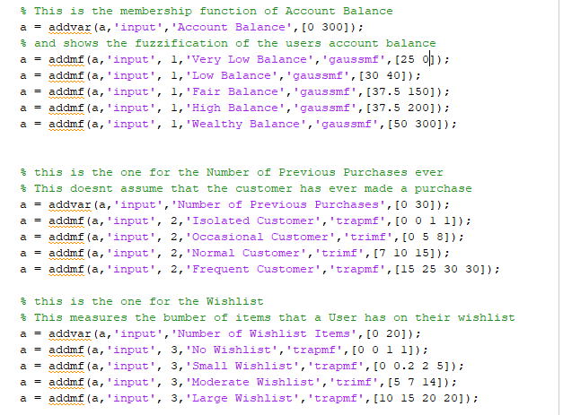

Fig 11. Membership functions for the Input Variables for System 1 of FIS 2

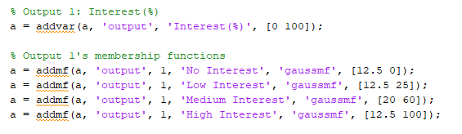

Fig 12. Membership functions for the Output Variables for the System 1 of FIS 2

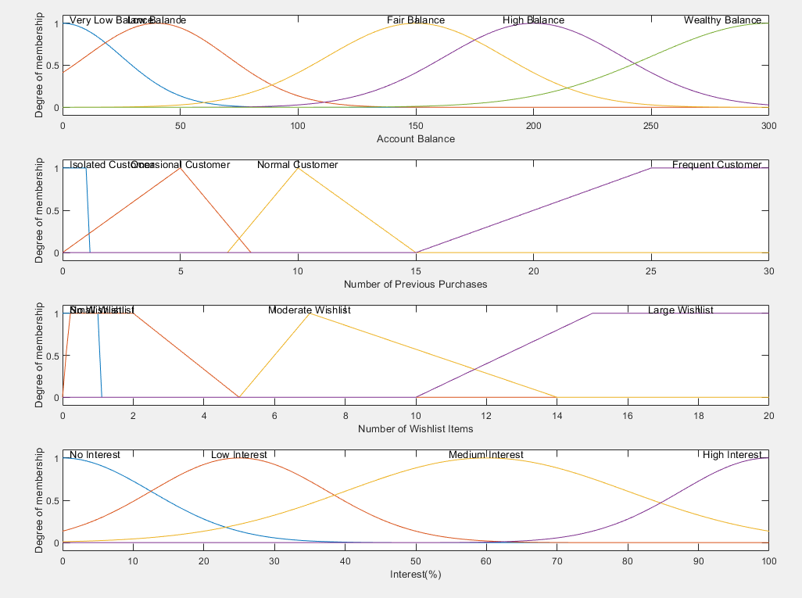

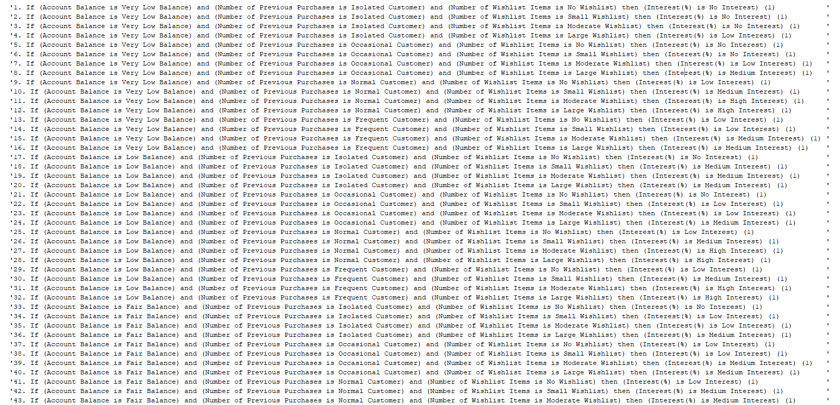Fig 13. The Distribution for the first FIS in the Second FIS

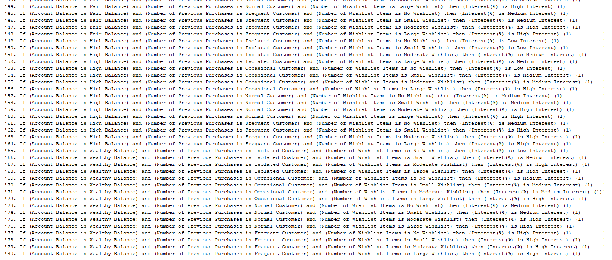

Fig 14. The Rulebase for the System1 in FIS 2

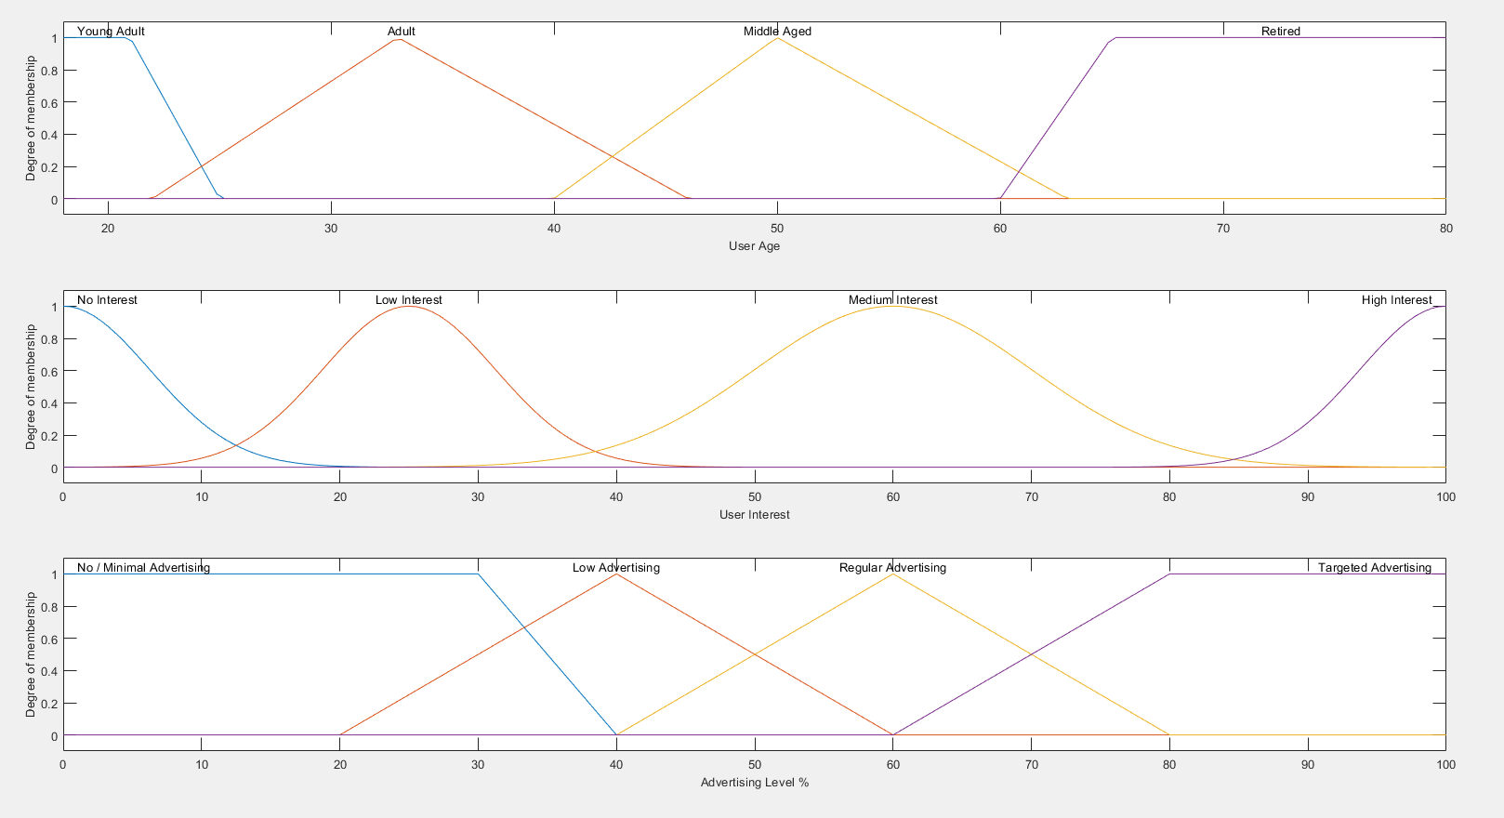

Fig 15. The Membership function for the System 1 in the FIS2

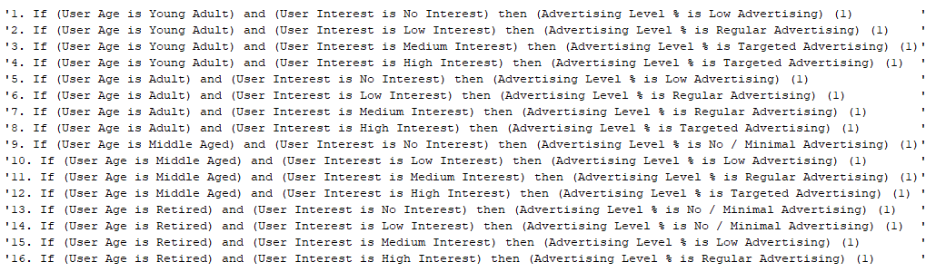

Fig 16. The Defuzzification Rules for the System 2 in FIS2

|  |  |  |  |  |
| --- | --- | --- | --- | --- |
|  |  |  |  |  |
| **Test Number** | **Account Balance** | **Number of Previous Purchases** | **Number of Items in Wishlist** | **Expected Outcome** |
| 1 | 175 | 18 | 19 | High Interest |
| 2 | 279 | 18 | 15 | High Interest |
| 3 | 5 | 15 | 15 | Medium Interest |
| 4 | 250 | 8 | 15 | High Interest |
| 5 | 180 | 17 | 18 | High Interest |
| 6 | 198 | 24 | 16 | High Interest |
| 7 | 70 | 19 | 13 | High Interest |
| 8 | 158 | 17 | 13 | High Interest |
| 9 | 63 | 14 | 11 | High Interest |
| 10 | 280 | 7 | 7 | Medium Interest |
| 11 | 107 | 15 | 8 | High Interest |
| 12 | 41 | 1 | 7 | Medium Interest |
| 13 | 281 | 11 | 9 | High Interest |
| 14 | 158 | 22 | 17 | High Interest |
| 15 | 18 | 22 | 13 | Medium Interest |
| 16 | 52 | 29 | 11 | Medium Interest |
| 17 | 221 | 8 | 15 | High Interest |
| 18 | 170 | 10 | 13 | Medium Interest |
| 19 | 151 | 7 | 3 | Low Interest |
| 20 | 77 | 17 | 8 | High Interest |
| 21 | 284 | 8 | 7 | High Interest |
| 22 | 87 | 11 | 12 | Medium Interest |
| 23 | 300 | 30 | 20 | High Interest (Maximum) |
| 24 | 14 | 23 | 8 | Medium Interest |
| 25 | 22 | 23 | 0 | No Interest |
| 26 | 15 | 5 | 3 | No Interest |
| 27 | 0 | 0 | 0 | No Interest (Minimum) |
| 28 | 16 | 1 | 1 | No Interest (Maximum) |
| 29 | 50 | 4 | 8 | Low Interest |
| 30 | 40 | 25 | 0 | Low Interest |
| 31 | 280 | 1 | 1 | Low Interest (High Balance) |
| 32 | 20 | 5 | 3 | Low Interest |

Fig. 17 – Test Data for System 1 FIS 2, with expected outcomes.

|  |  |  |  |  |  |  |  |  |  |
| --- | --- | --- | --- | --- | --- | --- | --- | --- | --- |
| **Test Number** | **Account Balance** | **Number of Previous Purchases** | **Number of Items in Wishlist** | **Expected Outcome** | **Interest Level (Output 1 - Centroid)** | **Interest Level (Output 1 - Bisector)** | **Interest Level (Output 1 - LOM)** | **Interest Level (Output 1 - MOM)** | **Interest Level (Output 1 - SOM)** |
| 1 | 175 | 18 | 19 | High Interest | 93.8305322 | 94 | 100 | 96 | 92 |
| 2 | 279 | 18 | 15 | High Interest | 93.83053222 | 94 | 100 | 96 | 92 |
| 3 | 5 | 15 | 15 | Medium Interest | 66.94658819 | 67 | 100 | 68.22807018 | 39 |
| 4 | 250 | 8 | 15 | High Interest | 93.70797341 | 94 | 100 | 95.5 | 91 |
| 5 | 180 | 17 | 18 | High Interest | 93.42172744 | 94 | 100 | 95 | 90 |
| 6 | 198 | 24 | 16 | High Interest | 95.22118432 | 96 | 100 | 99 | 98 |
| 7 | 70 | 19 | 13 | High Interest | 87.8713784 | 93 | 100 | 96.5 | 93 |
| 8 | 158 | 17 | 13 | High Interest | 93.42172526 | 94 | 100 | 95 | 90 |
| 9 | 63 | 14 | 11 | High Interest | 74.13662989 | 79 | 100 | 94.5 | 89 |
| 10 | 280 | 7 | 7 | Medium Interest | 59.99795816 | 60 | 74 | 60 | 46 |
| 11 | 107 | 15 | 8 | High Interest | 91.84202091 | 92 | 100 | 93.5 | 87 |
| 12 | 41 | 1 | 7 | Medium Interest | 49.66560087 | 56 | 60 | 60 | 60 |
| 13 | 281 | 11 | 9 | High Interest | 94.1153617 | 95 | 100 | 97.5 | 95 |
| 14 | 158 | 22 | 17 | High Interest | 94.89073632 | 95 | 100 | 98 | 96 |
| 15 | 18 | 22 | 13 | Medium Interest | 68.34499765 | 65 | 100 | 69.25 | 50 |
| 16 | 52 | 29 | 11 | Medium Interest | 75.99320359 | 82 | 100 | 96 | 92 |
| 17 | 221 | 8 | 15 | High Interest | 93.70797341 | 94 | 100 | 95.5 | 91 |
| 18 | 170 | 10 | 13 | Medium Interest | 76.69098574 | 83 | 100 | 97 | 94 |
| 19 | 151 | 7 | 3 | Low Interest | 46.82399753 | 48 | 74 | 46.14583333 | 16 |
| 20 | 77 | 17 | 8 | High Interest | 88.93600113 | 93 | 100 | 95 | 90 |
| 21 | 284 | 8 | 7 | High Interest | 92.77744624 | 94 | 100 | 95.5 | 91 |
| 22 | 87 | 11 | 12 | Medium Interest | 68.79206267 | 67 | 100 | 95.5 | 91 |
| 23 | 300 | 30 | 20 | High Interest (Maximum) | 95.3224455 | 96 | 100 | 100 | 100 |
| 24 | 14 | 23 | 8 | Medium Interest | 67.88197618 | 64 | 66 | 60 | 54 |
| 25 | 22 | 23 | 0 | No Interest | 25.45737483 | 25 | 28 | 25 | 22 |
| 26 | 15 | 5 | 3 | No Interest | 18.40588454 | 20 | 30 | 17.05882353 | 0 |
| 27 | 0 | 0 | 0 | No Interest (Minimum) | 4.677638942 | 4 | 0 | 0 | 0 |
| 28 | 16 | 1 | 1 | No Interest (Maximum) | 43.196774 | 52 | 4 | 2 | 0 |
| 29 | 50 | 4 | 8 | Low Interest | 28.48420918 | 26 | 29 | 25 | 21 |
| 30 | 40 | 25 | 0 | Low Interest | 26.71694697 | 25 | 25 | 25 | 25 |
| 31 | 280 | 1 | 1 | Low Interest (High Balance) | 46.68766305 | 51 | 64 | 47.5 | 23 |
| 32 | 20 | 5 | 3 | Low Interest | 18.4065359 | 20 | 30 | 17.05882353 | 0 |

Fig 18. Output Test Data for System1 of FIS2 – with different Defuzzification Methods

|  |  |  |  |
| --- | --- | --- | --- |
| **Test Number** | **Interest Level (Output 1 - Centroid)** | **User Age** | **Expected outcome** |
| 1 | 93.83053 | 21 | Targeted Adverts |
| 2 | 93.83053 | 64 | Regular Adverts |
| 3 | 66.94659 | 48 | Regular Adverts |
| 4 | 93.70797 | 25 | Targeted Adverts |
| 5 | 93.42173 | 24 | Targeted Adverts |
| 6 | 95.22118 | 64 | Regular Adverts |
| 7 | 87.87138 | 30 | Targeted Adverts |
| 8 | 93.42173 | 49 | Targeted Adverts |
| 9 | 74.13663 | 61 | Regular Adverts |
| 10 | 59.99796 | 79 | Low Advertising |
| 11 | 91.84202 | 30 | Targeted Adverts |
| 12 | 49.6656 | 77 | Low Advertising |
| 13 | 94.11536 | 23 | Targeted Adverts |
| 14 | 94.89074 | 68 | Regular Adverts |
| 15 | 68.345 | 48 | Regular Adverts |
| 16 | 75.9932 | 45 | Regular Adverts |
| 17 | 93.70797 | 44 | Targeted adverts |
| 18 | 76.69099 | 68 | Low Advertising |
| 19 | 46.824 | 22 | Targeted adverts |
| 20 | 88.936 | 27 | Targeted adverts |
| 21 | 92.77745 | 26 | Regular Advertising |
| 22 | 68.79206 | 47 | Regular Advertising |
| 23 | 95.32245 | 58 | Targeted adverts |
| 24 | 67.88198 | 22 | Targeted adverts |
| 25 | 25.45737 | 35 | Regular Advertising |
| 26 | 18.40588 | 21 | Regular Advertising |
| 27 | 4.677639 | 35 | Low Advertising |
| 28 | 43.19677 | 55 | Regular Adverts |
| 29 | 28.48421 | 68 | No / Minimal Advertising |
| 30 | 26.71695 | 21 | Regular Adverts |
| 31 | 46.68766 | 35 | Regular Adverts |
| 32 | 18.40654 | 55 | Low Advertising |

Fig 19a. System2 FIS 2 Test data and expected outcome.

|  |  |  |  |  |  |  |  |  |
| --- | --- | --- | --- | --- | --- | --- | --- | --- |
| **Test Number** | **Interest Level (Output 1 - Centroid)** | **User Age** | **Advertising Level (Output 2) CENTROID** | **Advertising Level (Output 2) BISECTOR** | **Advertising Level (Output 2) MOM** | **Advertising Level (Output 2) LOM** | **Advertising Level (Output 2) SOM** | **Expected outcome** |
| 1 | 93.83053 | 21 | 83 | 83 | 86.5 | 100 | 73 | Targeted Adverts |
| 2 | 93.83053 | 64 | 60 | 60 | 60 | 67 | 53 | Regular Adverts |
| 3 | 66.94659 | 48 | 60 | 60 | 60 | 64 | 56 | Regular Adverts |
| 4 | 93.70797 | 25 | 81 | 81 | 83 | 100 | 66 | Targeted Adverts |
| 5 | 93.42173 | 24 | 81 | 81 | 82.5 | 100 | 65 | Targeted Adverts |
| 6 | 95.22118 | 64 | 60 | 60 | 60 | 65 | 55 | Regular Adverts |
| 7 | 87.87138 | 30 | 80 | 80 | 82 | 100 | 64 | Targeted Adverts |
| 8 | 93.42173 | 49 | 83 | 83 | 86 | 100 | 72 | Targeted Adverts |
| 9 | 74.13663 | 61 | 48 | 48 | 40 | 56 | 24 | Regular Adverts |
| 10 | 59.99796 | 79 | 40 | 40 | 40 | 40 | 40 | Low Advertising |
| 11 | 91.84202 | 30 | 82 | 82 | 84.5 | 100 | 69 | Targeted Adverts |
| 12 | 49.6656 | 77 | 40 | 40 | 40 | 48 | 32 | Low Advertising |
| 13 | 94.11536 | 23 | 83 | 83 | 85 | 100 | 70 | Targeted Adverts |
| 14 | 94.89074 | 68 | 60 | 60 | 60 | 65 | 55 | Regular Adverts |
| 15 | 68.345 | 48 | 60 | 60 | 60 | 65 | 55 | Regular Adverts |
| 16 | 75.9932 | 45 | 60 | 60 | 60 | 74 | 46 | Regular Adverts |
| 17 | 93.70797 | 44 | 82 | 82 | 84 | 100 | 68 | Targeted adverts |
| 18 | 76.69099 | 68 | 40 | 40 | 40 | 55 | 25 | Low Advertising |
| 19 | 46.824 | 22 | 82 | 82 | 84.5 | 100 | 69 | Targeted adverts |
| 20 | 88.936 | 27 | 81 | 81 | 82.5 | 100 | 65 | Targeted adverts |
| 21 | 92.77745 | 26 | 82 | 82 | 84 | 100 | 68 | Regular Advertising |
| 22 | 68.79206 | 47 | 60 | 60 | 60 | 66 | 54 | Regular Advertising |
| 23 | 95.32245 | 58 | 82 | 82 | 84 | 100 | 68 | Targeted adverts |
| 24 | 67.88198 | 22 | 84 | 84 | 87.5 | 100 | 75 | Targeted adverts |
| 25 | 25.45737 | 35 | 60 | 60 | 60 | 63 | 57 | Regular Advertising |
| 26 | 18.40588 | 21 | 60 | 60 | 60 | 68 | 52 | Regular Advertising |
| 27 | 4.677639 | 35 | 40 | 40 | 40 | 44 | 36 | Low Advertising |
| 28 | 43.19677 | 55 | 59 | 59 | 60 | 75 | 45 | Regular Adverts |
| 29 | 28.48421 | 68 | 18 | 18 | 15.5 | 31 | 0 | No / Minimal Advertising |
| 30 | 26.71695 | 21 | 60 | 60 | 60 | 60 | 60 | Regular Adverts |
| 31 | 46.68766 | 35 | 60 | 60 | 60 | 71 | 49 | Regular Adverts |
| 32 | 18.40654 | 55 | 40 | 40 | 40 | 48 | 32 | Low Advertising |

Fig 19b. Output Test data for FIS2 of FIS2 – with different Defuzzification Methods